A comprehensive comparison report on EblueSoft Infotech

Ebluesoft Technologies primarily focuses on :
Digital Marketing
AI solutions
SEO optimization
Website Development
App Development
Graphic Design
Content Writing

I’ll focus on these domains separately and gather data first. For now I’ll focus on first 20 Indian companies for every domain. Source: Clutch.co

I’ll cover Industry Distributions, Client list, Opportunities for each Domains

Industry Distributions
- Digital Marketing Industry Distribution

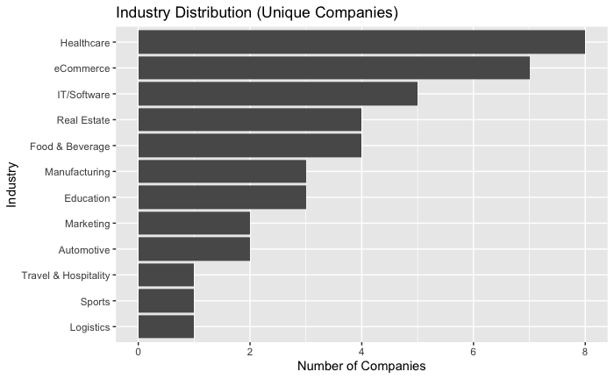
Top Industries that companies target are : Healthcare, eCommerce, IT, Real Estate.

Healthcare and eCommerce are the most saturated industries for digital marketing. Real Estate and Food & Beverage have moderate competition. The best opportunities are Manufacturing and Education as they have the fewest competitors but still show decent demand based on previous matrices.

- App Development Industry Distribution

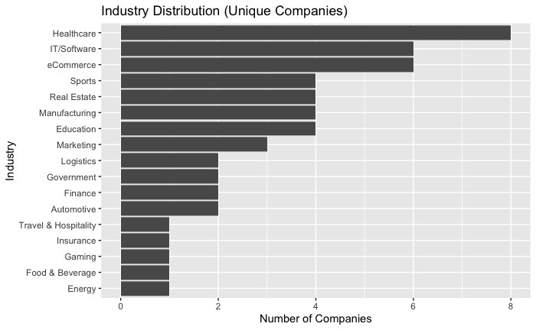

Top Industries that companies target are : Healthcare, eCommerce, IT, Sports.

App development is heavily saturated in these. The opportunities lie in Education, Marketing, Logistics, and Government as these industries have the fewest competitors. Real Estate and Manufacturing sit in the middle, approachable but not prime.

- Graphic Design Industry Distribution

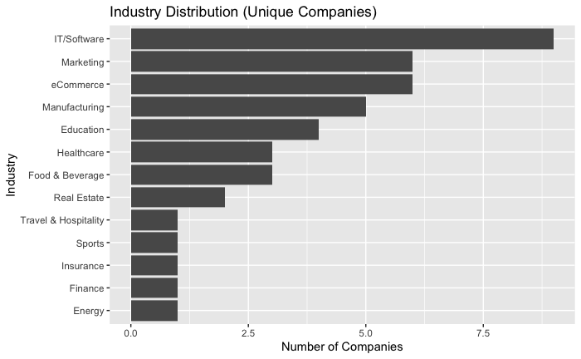

Top Industries that companies target are : eCommerce, IT, Marketing, Education

The best opportunities are Real Estate, Travel & Hospitality and Sports (1.2) . Manufacturing (5) and Education (4) are also viable but more competitive.

4. SEO Industry Distribution

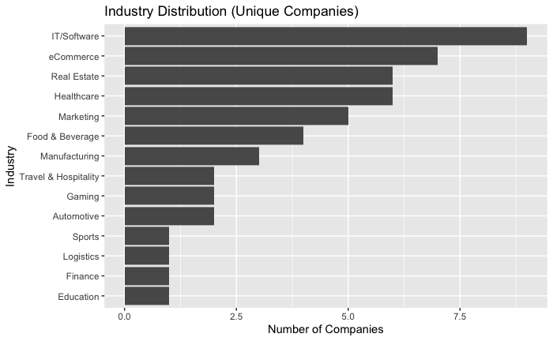

Top Industries that companies target are : Healthcare, eCommerce, IT, Real Estate.

We should go for Education, Travel and Hospitality, Automation

5. Web Development Industry Distribution

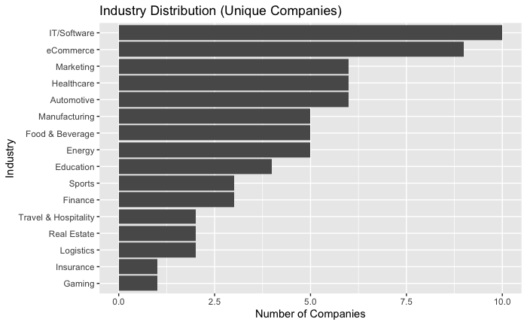

Top Industries that companies target are : Healthcare, eCommerce, IT, Marketing. The best opportunities are industries with the fewest competitors: Real Estate, Logistics , Insurance, Gaming, Finance .

Final Strategic Recommendation

IT/Software and eCommerce are overcrowded across ALL service lines – avoid them as primary targets.

The best opportunities for eBluesoft are:
Education – especially for SEO (lowest competition at 0.8) and Digital Marketing
Real Estate – especially for Web Development (2.2) and Graphic Design
Logistics & Gaming – niche opportunities for Web Development and SEO
Sports – a consistent low-competition industry across Graphic Design, SEO, and Web Development
Focus sales efforts on Education, Real Estate, and Sports to avoid the crowded IT/eCommerce space.
CLIENT LISTS BY SERVICE LINE

1. SEO Client List (Competitors' Top Clients)

Seerion Technologies (IT/Software)
Michael Tinnon & Associates (Real Estate)
HFA Society (Healthcare)
Fashion Brand (Negative Review)
Event Planning Agency
Corporate Rentals (Furniture Rental)
Codeyoung (Education - Negative Review)
Backyard Valley Tea (Food & Beverage)
Aashakiran Hospital (Healthcare - Fertility)

Key Takeaway: SEO competitors are winning in IT/Software, Real Estate, and Healthcare. Note the negative reviews from Fashion and Education – approach these with caution.

1.2 Web Development Client List (Competitors' Top Clients)

IT Company (Generic)
Think Renewable (Energy)
The Script Craft (Creative/Media)
Temple University (Education)
Software Development Company (IT)
Samuel Son & Co (Manufacturing)
Real Estate Company (Real Estate)
Luminous (Marketing Agency)
Fmcg Markets (FMCG/Retail)
Expert Witness Gateway (Legal)

Key Takeaway: Web development competitors are winning in Energy, Education, Manufacturing, and Real Estate. Notice the absence of large eCommerce clients – institutional and industrial clients are the sweet spot.

1.3 App Development Client List (Competitors' Top Clients)

Whirlpool (Manufacturing)
Red Bull (Beverage)
Radiance Travel (Travel)
Nike (Retail/Fashion)
NASA (Government/Space)
Kara Water (Consumer Goods)
Gleam (Tech/Startup)
Fortune 500 Real Estate Firm (Real Estate)
ESPN (Sports/Media)
AXA (Insurance/Finance)

Key Takeaway: Competitors have won major global brands (Nike, Red Bull, ESPN, NASA). These are not realistic targets. However, the Fortune 500 Real Estate firm proves Real Estate is viable. Focus on Real Estate and Manufacturing.

1.4 Digital Marketing Client List (Competitors' Top Clients)

Zapit (Crypto/Fintech)
The Kraft Heinz Company (Food & Beverage)
Octonius (Tech/Productivity)
McKinley Rice (Business Services)
Home&We Limited (Retail/E-commerce)
Ekalavya Hansaj Inc (Consulting)
Dunkin Donuts (Food & Beverage)
Animal Care Company (Healthcare/ Veterinary)
Action Analysis (Marketing/Analytics)
A.G Diagnostics (Healthcare)

Key Takeaway: Competitors win with Food & Beverage (Kraft Heinz, Dunkin) and Healthcare (A.G Diagnostics). Product-based industries and service-based industries respond best to digital marketing.

1.5 Graphic Design Client List (Competitors' Top Clients)

Verico (Mortgage/Finance)
Tigerblocks (Management/Finance)
Resene (Manufacturing - Paint)
Radisson Hotel Group (Hospitality)
Qonto (Fintech)
PGC Legal (Legal)
Papier Ltd (Retail/Stationery)
Greenoaks (Investment)
Article Ten (Creative Agency)

Key Takeaway: Competitors win with Manufacturing (Resene) and Hospitality (Radisson). These industries need consistent design work but are not typically targeted by digital-first agencies.

OPPORTUNITY MATRICES BY SERVICE LINE

Each matrix shows Competition (X-axis) vs Demand (Y-axis). Target industries with HIGH demand and LOW competition.

- App Development Opportunity Matrix

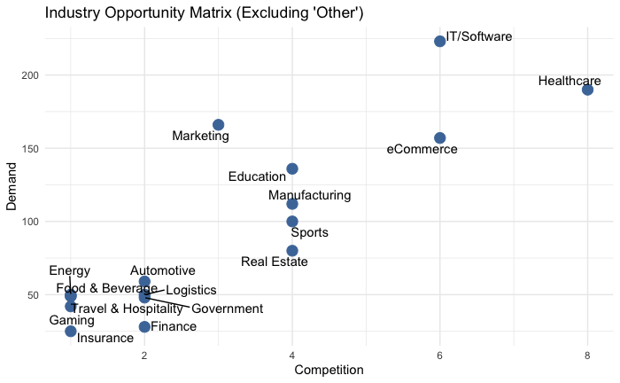

PRIME TARGETS (High Demand, Low Competition):

Real Estate - Demand 95, Competition 3.5
Education - Demand 130, Competition 3.5
Manufacturing - Demand 110, Competition 3.5
Sports - Demand 100, Competition 3.5

AVOID (High Demand, High Competition):

IT/Software - Demand 175, Competition 5.8
Healthcare - Demand 180, Competition 6.8
eCommerce - Demand 160, Competition 5.5

IGNORE (Low Demand):

Energy, Automotive, Food & Beverage, Logistics, Travel, Government, Finance, Insurance (Demand ~50, Competition 1.5)

- Digital Marketing Opportunity Matrix

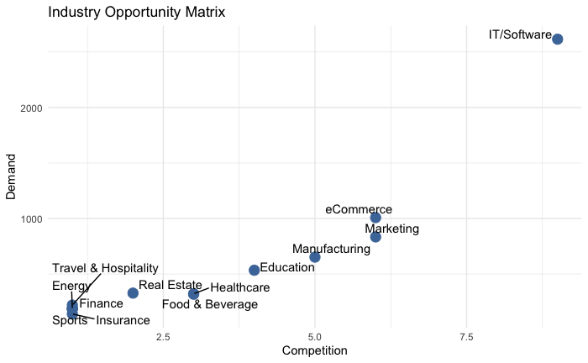

PRIME TARGETS (High Demand, Low Competition):

Real Estate - Demand 700, Competition 4.2
Healthcare - Demand 600, Competition 4.0
Education - Demand 800, Competition 4.5

AVOID (High Demand, High Competition):

IT/Software - Demand 1800, Competition 5.2
eCommerce - Demand 1200, Competition 5.0
Marketing - Demand 1000, Competition 5.0
Manufacturing - Demand 900, Competition 4.8

SECONDARY TARGETS:

Travel & Hospitality - Demand 500, Competition 3.8
Energy - Demand 400, Competition 3.5

IGNORE: Finance, Food & Beverage, Sports, Insurance

- Graphic Design Opportunity Matrix
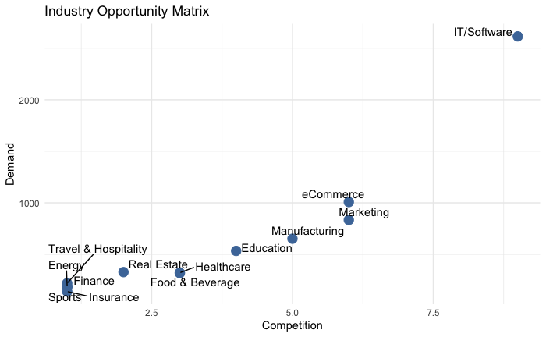

PRIME TARGETS (High Demand, Low Competition):

Education - Demand 800, Competition 4.5
Manufacturing - Demand 900, Competition 4.8
Healthcare - Demand 600, Competition 4.0

AVOID (High Demand, High Competition):

IT/Software - Demand 1800, Competition 5.2
eCommerce - Demand 1200, Competition 5.0
Marketing - Demand 1000, Competition 5.0

SECONDARY TARGETS:

Real Estate - Demand 700, Competition 4.2
Food & Beverage - Demand 500, Competition 3.8

IGNORE: Travel, Energy, Finance, Sports, Insurance

- SEO Opportunity Matrix

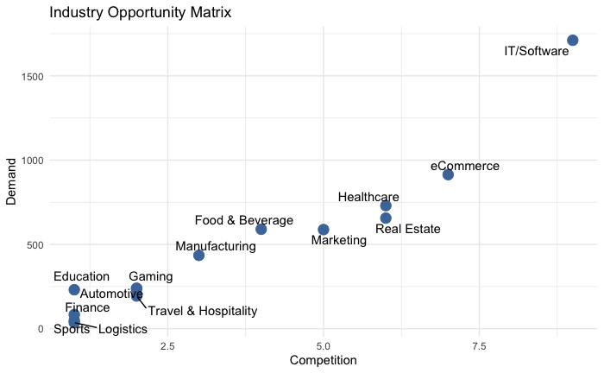

PRIME TARGETS (High Demand, Low Competition):

Real Estate - Demand 600, Competition 5.5
Healthcare - Demand 700, Competition 5.0
Education - Demand 300, Competition 2.5

AVOID (High Demand, High Competition):

IT/Software - Demand 1600, Competition 6.5
eCommerce - Demand 900, Competition 7.5

SECONDARY TARGETS:

Marketing - Demand 550, Competition 5.0
Manufacturing - Demand 450, Competition 3.0
Food & Beverage - Demand 400, Competition 3.5

IGNORE: Automotive, Finance, Travel, Sports, Logistics (Demand 150-250)

- Web Development Opportunity Matrix

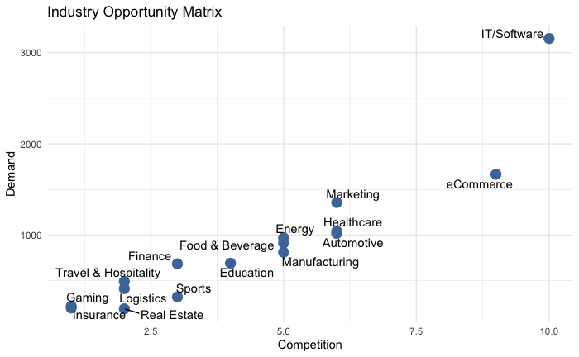

PRIME TARGETS (High Demand, Low Competition):

Real Estate - Demand 100, Competition 2.5
Sports - Demand 50, Competition 2.5

AVOID (High Demand, High Competition):

IT/Software - Demand 3100, Competition 8.5
eCommerce - Demand 1600, Competition 7.5
Marketing - Demand 1100, Competition 5.0
Healthcare - Demand 1000, Competition 4.5

SECONDARY TARGETS:

Automotive - Demand 900, Competition 4.5
Manufacturing - Demand 800, Competition 4.5
Energy - Demand 700, Competition 4.5
Food & Beverage - Demand 600, Competition 4.5

IGNORE: Finance, Travel, Gaming, Logistics (Demand 200-500)

RECOMMENDATIONS

IT/Software and eCommerce are overcrowded across ALL service lines – avoid them as primary targets.

The best opportunities for eBluesoft are:

1. Education – especially for SEO (lowest competition at 0.8) and Digital Marketing
2. Real Estate – especially for Web Development (2.2) and Graphic Design
3. Logistics & Gaming – niche opportunities for Web Development and SEO
4. Sports – a consistent low-competition industry across Graphic Design, SEO, and Web Development

Where eBluesoft stands

eBluesoft performs consistently well (4/5) in:

- Digital Marketing
- SEO
- Web Development
- App Development
This puts the company in a solid mid-to-upper competitive tier.
However, two clear weaknesses stand out:
- AI Solutions (2/5) → significantly behind top competitors
- Client Strength (3/5) → weaker credibility and brand trust

TOP COMPETITORS

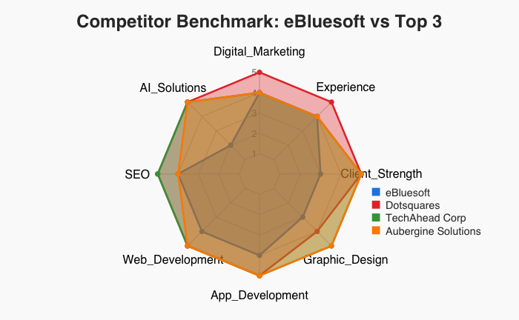

Across the analysis, the strongest competitors include:

Dotsquares – Consistently high across all domains, especially Web Development and App Development. Scores 5/5 in most parameters. Has 27,000+ projects and 18,500+ clients. Very Low Risk credit rating.

TechAhead Corp – Dominant in App Development and AI Solutions. Holds SOC 2, ISO 27001, and ISO 42001 certifications. AWS Advanced Partner. Webby Award winner. Clients include AXA, ESPN, ICC.

Aubergine Solutions – Strong in AI, UX, and product-focused development. Red Dot Award winner. Great Place to Work certified. Has delivered 400+ products and helped clients raise $1B+ in funds.

These companies are strong across all domains AND have very high client credibility (scoring 5/5 on Client Strength).

How eBluesoft Compares:

eBluesoft is competitive in execution – scoring 4/5 in Digital Marketing, SEO, Web Development, and App Development.

But eBluesoft lacks two critical things:

1. Advanced capabilities – especially AI Solutions (score 2/5 vs competitors' 5/5)
2. Market positioning – weak client portfolio, lack of case studies, poor brand visibility (Client Strength score 3/5 vs competitors' 5/5.

WHERE TO FOCUS – MARKET OPPORTUNITIES

From the industry analysis, three sectors stand out as the best opportunities for eBluesoft.

Real Estate – Best Immediate Opportunity

Appears across multiple service lines: SEO, Digital Marketing, App Development, Web Development, Graphic Design. Shows high demand but low competition in most matrices.

Example: Web Development competition for Real Estate is only 2.2 (very low) while demand exists.

Healthcare

High demand across SEO (Demand 700, Competition 5.0) and Digital Marketing (Demand 600, Competition 4.0). Consistent need for SEO and digital presence. Good for specialized service positioning.

Manufacturing

Low competition across multiple domains. App Development competition: 3.5. Graphic Design competition: 5.0. Web Development competition: 4.5. Underserved market, especially for design and web development. Target for design and development work.

Industries to Avoid

IT/Software – Overcrowded across ALL service lines. Web Development competition: 8.5. SEO competition: 6.5. App Development competition: 5.8.

eCommerce – Also overcrowded. Web Development competition: 7.5. Digital Marketing competition: 5.0. SEO competition: 7.5.

CLEAR PRIORITIES

Priority 1: Fix the Biggest Gap – AI Solutions

Current score: 2/5. Top competitors score: 5/5.

This is the main reason competitors outrank you.

-- Add AI services – even if starting small. Examples: AI-powered chatbots for websites, automation workflows, predictive analytics for clients, AI content generation tools.

-- Create an "AI Solutions" service page on the eBluesoft website.

Priority 2: Improve Client Credibility

Current score: 3/5. Top competitors score: 5/5.

Your competitors look stronger because they show their credibility better. You have 300+ clients but nobody knows their names.

--Collect 5 to 10 video testimonials from existing happy clients.

--Add client logos to the website homepage. Publish 3 detailed case studies (Real Estate, Healthcare, Manufacturing focus).

**--Get listed on Clutch.co with 10+ verified reviews.

Priority 3: Focus Instead of Spreading Thin

Current positioning is too broad. "We do everything for everyone" is not a strategy.

--Change positioning from generic to specific. Instead of "Web Development Company in Kolkata", use "Real Estate Digital Solutions Provider" or "Healthcare SEO & Marketing Agency".
--Create two industry-specific landing pages on the website: Real Estate Digital Solutions, Healthcare SEO & Marketing. Train sales team to lead with Real Estate and Healthcare, not generic IT.

Priority 4: Strengthen Graphic Design

Current score: 3/5. Top competitors score: 4.7/5.

This affects branding, pitch decks, and perceived quality. Weak design makes the entire company look less professional.

--Create a professional pitch deck template.

--Standardize all client deliverables with branded templates.

